**Website Hosting**

**Commands (All The Process are performed in PUTTY)**

*sudo -I*

*apt-get update*

*apt-get install apache2*

*systemctl start apache2*

**if not working apache webserver so type next command**

*systemctl status apache2*

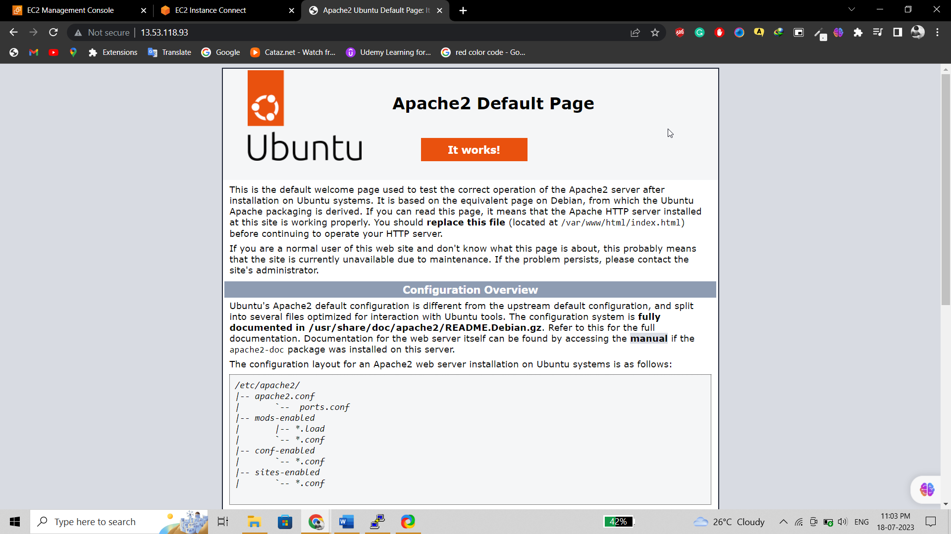

**Now Open The Soft WinSCP**

**And Connect To Server**

**Then Go to PUTTY Terminal and Enter The File Command**

Ls

Cd (Project File Name)/

cd..

(if Any Deny Error are There Then Before Command Write sudo) {cp(CP MEANS COPY FILE) -r Project/* /var/www/html

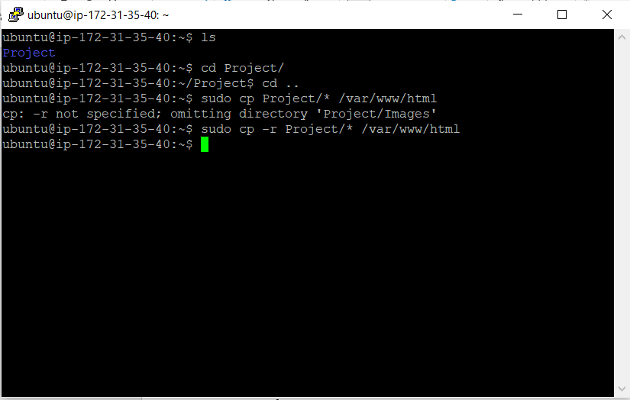

**Final Hosting Output :**



If We Install linux username is **ec2-user**

**Sudu vi index.php**

**For exit (:wq)**